Here is a mashup application based on google charts

I took three charts

1) pie chart

2) work flow chart

3) bar chart.

AND result of pie chart is as below

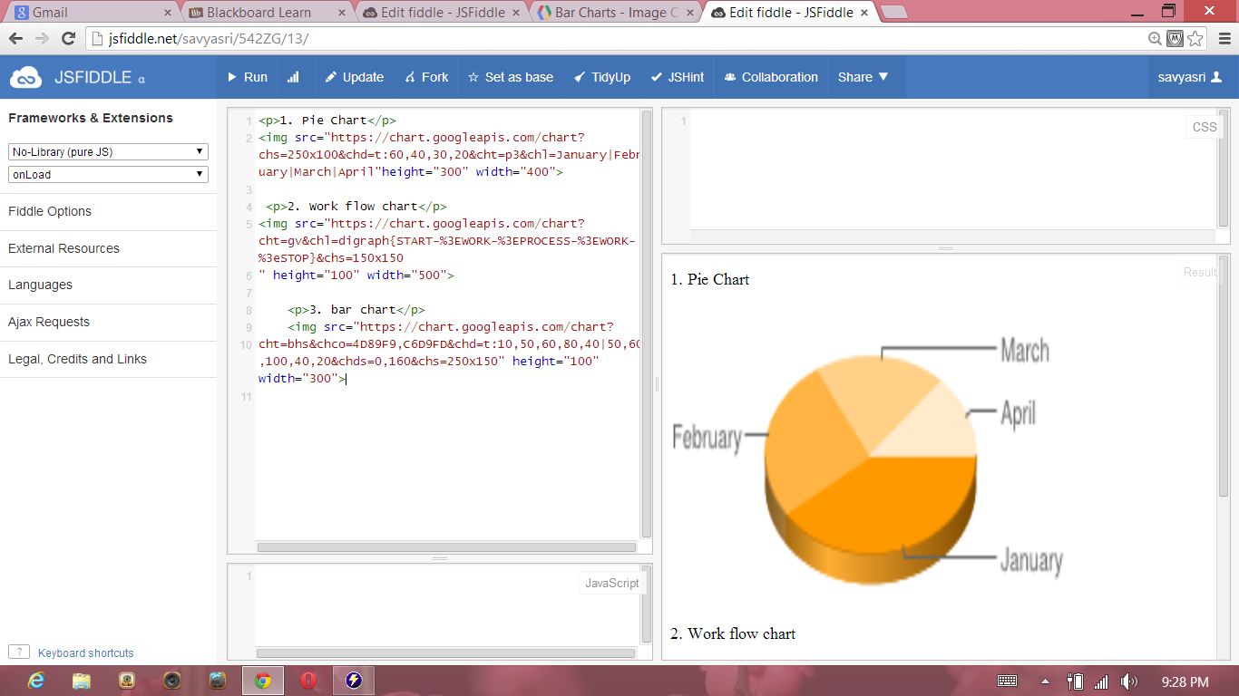

RESULTS OF WORK FLOW CHART AND BAR CHART

